Public Meeting

A change is proposed for lands municipally known as 8127 & 8149 Yonge Street. The City of Markham received complete Official Plan and Zoning By-law Amendment applications, submitted by Malone Given Parsons c/o DRC (Markham) Inc – 8127-8149 Yonge St on August 23, 2022. You are receiving this notice because you live within 200 metres of the property and are being invited to participate in the review process.

Tell us what you think
A Public Meeting to consider the applicant’s proposal for the subject property will take place on:

Date: March 28, 2023
Time: 7:00 p.m.
Place: Members of the Development Services Committee and the public have the option to attend either in-person in the Council Chamber at the Civic Centre or remotely via Zoom.

All meetings are video and audio streamed on the City’s website at:
https://pub-markham.escribemeetings.com/
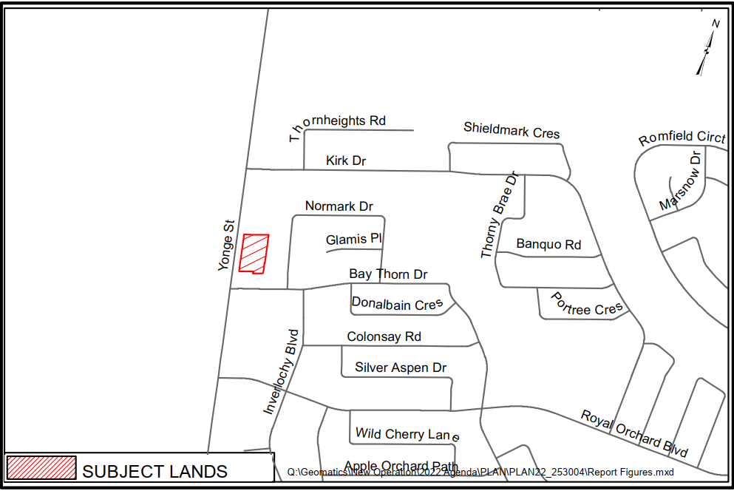
Property Description

The subject lands are 0.709 ha (1.75 ac) in size, and located on the east side of Yonge Street, north of Bay Thorn Drive (see Figure 1 – Key Map). The subject lands are currently occupied by a 2-storey multi-unit commercial building.
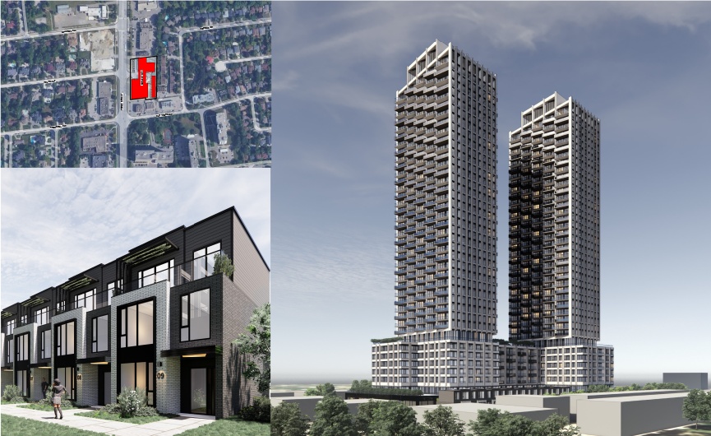
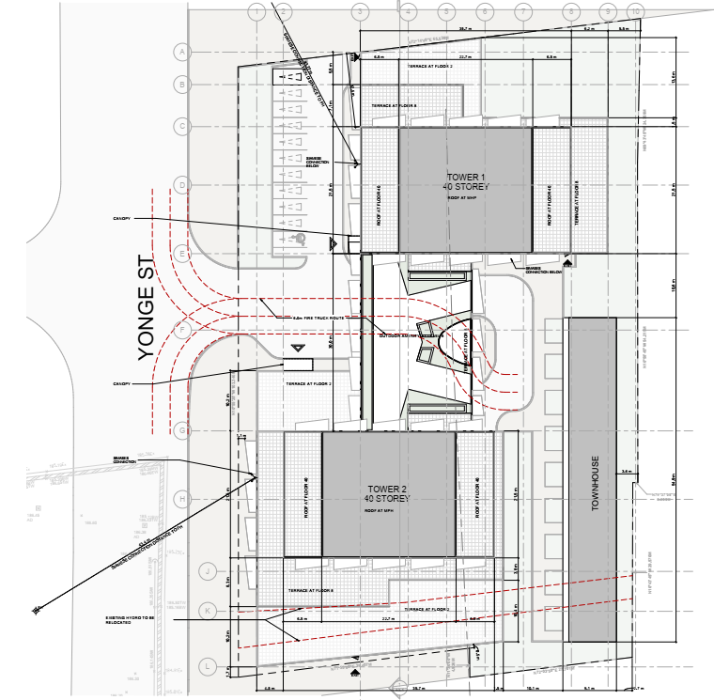
Applicant’s Proposal

- Two 40-storey high-rise residential towers above a 7-storey podium, and nine 3-storey townhouse units.
- Total of 865 residential units;
- The total residential gross floor area is 69,655.2 m2 (749,773 ft2) and the total retail gross floor area is 1,191.0 m2 (12,831 ft2);
- Total of 9.99 FSI is proposed;
- There are also four-levels of below grade parking, limited surface parking, outdoor and indoor amenity space, and vehicle and pedestrian access to Yonge Street.
Public Meeting Information Report
For additional information about the application open Public Meeting Information Report from this link to find Application File Number PLAN 22 118754 https://www.markham.ca/PlanningApplications.

Additional Information
Members of the public who wish to speak at the electronic Public Meeting through a virtual deputation, may do so by completing the Request to Speak form located online at www.markham.ca, by emailing the Clerk’s Office at notifications@markham.ca or by calling 905-479-7760 prior to the meeting. Please provide a full name, contact information and identify the item you wish to speak to so that information can be provided on how you can make a virtual deputation.

Members of the public may submit written deputations by email to notifications@markham.ca.

Please note that all proceedings of the Public Meeting are recorded.

If you cannot attend the meeting but wish to provide comments or speak with the Planner, please contact:

Nusrat Omer, Senior Planner, Planning & Urban Design Department, nomer@markham.ca, (905) 477-7000 ext. 2185, Refer to application number PLAN 22 253004

Future Notification
If you wish to be notified of the decision of the City of Markham, or approval authority, on the proposed Official Plan and Zoning By-law Amendment application’s, you must make a written request to the Clerk’s Department at the address noted above or by email to clerkspublic@markham.ca.

Information about Appeals
i. If a person or public body would otherwise have an ability to appeal the decision of the Council of the City of Markham, or the approval authority, to the Local Planning Appeal Tribunal but the person or public body does not make oral submissions at a public meeting or make written submissions to the City of Markham before the proposed official plan amendment is adopted or the by-law is passed, the person or public body is not entitled to appeal the decision.

ii. If a person or public body does not make oral submissions at a public meeting, or make written submissions to the City of Markham before the proposed official plan amendment is adopted or the by-law is passed, the person or public body may not be added as a party to the hearing of an appeal before the Local Planning Appeal Tribunal unless, in the opinion of the Tribunal, there are reasonable grounds to do so.

That means if this this official plan amendment or by-law is appealed to the Local Planning Appeal Tribunal and you would like to participate in the appeal in some form, you must make an oral submission at a public meeting, or submit written comments to the City Clerk, before the official plan amendment is adopted or the by-law is passed by Markham City Council.

Notice to Landlords
If you are a landlord of lands containing seven (7) or more residential units, please post a copy of this notice in a location that is visible to all of the residents.

Personal Information
Personal information collected in response to this planning notice will be used to assist City staff and Council to process this application and will be made public.

Date of Notice: March 8, 2023

Arvin Prasad, MCIP, RPP Jim Jones
Commissioner of Development Services Chair
Development Services Committee

