

September 1, 2021

**Cast Iron Watermain Rehabilitation John St, 14th Ave, Lyndhurst Dr and Esna Park Dr**

**Contract: 155-T-21**

**NOTICE OF CONSTRUCTION/ROAD RESTRICTIONS**

Dear Resident/Business Owner,

As part of Markham’s continuing commitment to maintain the City’s water distribution system, the City will be undertaking watermain rehabilitation on the following streets in 2021 and 2022:

* John St- West of CNR Crossing to Leslie/Don Mills
* 14th Ave- West of Woodbine Ave
* Lyndhurst Dr- East of Cummings Ct
* Esna Park Dr- Woodbine Ave to Rodick Rd

The limits of these works can be found under Attachment “A”.

Construction is scheduled to begin the week of Sept 7th, 2021, with anticipation that substantial completion will be reached for Fall 2022. Construction works will commence on John St between the CNR Crossing to Chestnut Gate and 14th Ave West of Woodbine. Some construction works on John St and 14th Ave will be taking place simultaneously. The works will be scheduled to minimize disruption as much as possible while also ensuring the project is completed within the required timeframe.

The work involves cleaning and then structural lining of the existing watermains. During the rehabilitation work, sections of watermain will be temporarily out of service and several access pits will be excavated along the watermains with all mainline valves and fire hydrants being replaced. Businesses and residential neighbourhoods will be connected to a temporary aboveground water system. The temporary aboveground water system & services are passed through water quality sampling and testing to ensure the quality of your drinking water. **Please be aware of the above ground water pipes in your area during construction.**

The Contractor for this project is Fer-Pal Construction Ltd. and the Consulting Engineer is Accardi Schaeffers & Associates Ltd. While inconveniences are expected as a result of construction activities, the City of Markham will take all reasonable steps to minimize the impacts. All areas disturbed during construction will be restored to their original condition. Further details on what residents can expect are outlined below:

**1. Driveway Access**

Driveway access may be temporarily interrupted during construction. However, this inconvenience will be kept to a minimum.

**2. Disruptions**

Vehicle and pedestrian traffic will be disrupted through lanes restriction and sidewalk closures.

* Signs will be posted to advise of detours, lane closures and pedestrian crossings.
* Emergency (police, fire and medical response) access will be maintained at all times.
* If required due to lack of access, the contractor will assist in domestic garbage removal on scheduled garbage pickup dates.

Temporary disruptions to the water supply may occur during the construction period though further notice will be given prior to any scheduled water supply disruption and residents/businesses will be informed if additional precautions are to be taken during any water supply disruptions.

**3. Parking**

All parking signs and regulations must be complied with when parking on adjacent streets. The *Overnight Parking Prohibited By-law* will be waived to those unable to access their driveway. Residents are advised not to park where on-street parking is prohibited. There will be no consideration for parking offences in areas designated as No Stopping or No Standing. In addition, the following restrictions still apply:

• No stopping on sidewalks or boulevards,

• No stopping by fire hydrants, fire routes, rush hour routes, and

• No parking within 9 meters of intersections.

**4. Removal of Private Items from City Property**

Features such as but not limited to landscaping, fences, irrigation systems or other physical features at businesses or residential areas are located on City property. These features may be in the way of the construction. In such cases, businesses and residents are advised to remove these items prior to the beginning of construction. **The City will not be responsible for damage to any privately-owned items installed on the City’s property.**

**5. Work Hours**

Work will typically take place from 7:00 a.m. to 7:00 p.m. from Monday to Friday. If there is any occasional Saturday work, such work will be from 9:00 a.m. to 5:00 p.m.

**7. Contact**

We look forward to working with you in having our Contractor complete this project in a professional and timely manner. Should you require further information or if you have any questions or concerns regarding this project, please feel free to contact the City of Markham’s Contact Centre at (905) 477-5530.

Thank you in advance for your co-operation and patience. Sincerely,

Richard Kit, P.Eng.

Sr. Infrastructure Project Engineer

Environmental Services Department

Tel: (905) 477-7000 ext. 2639

RKit@markham.ca

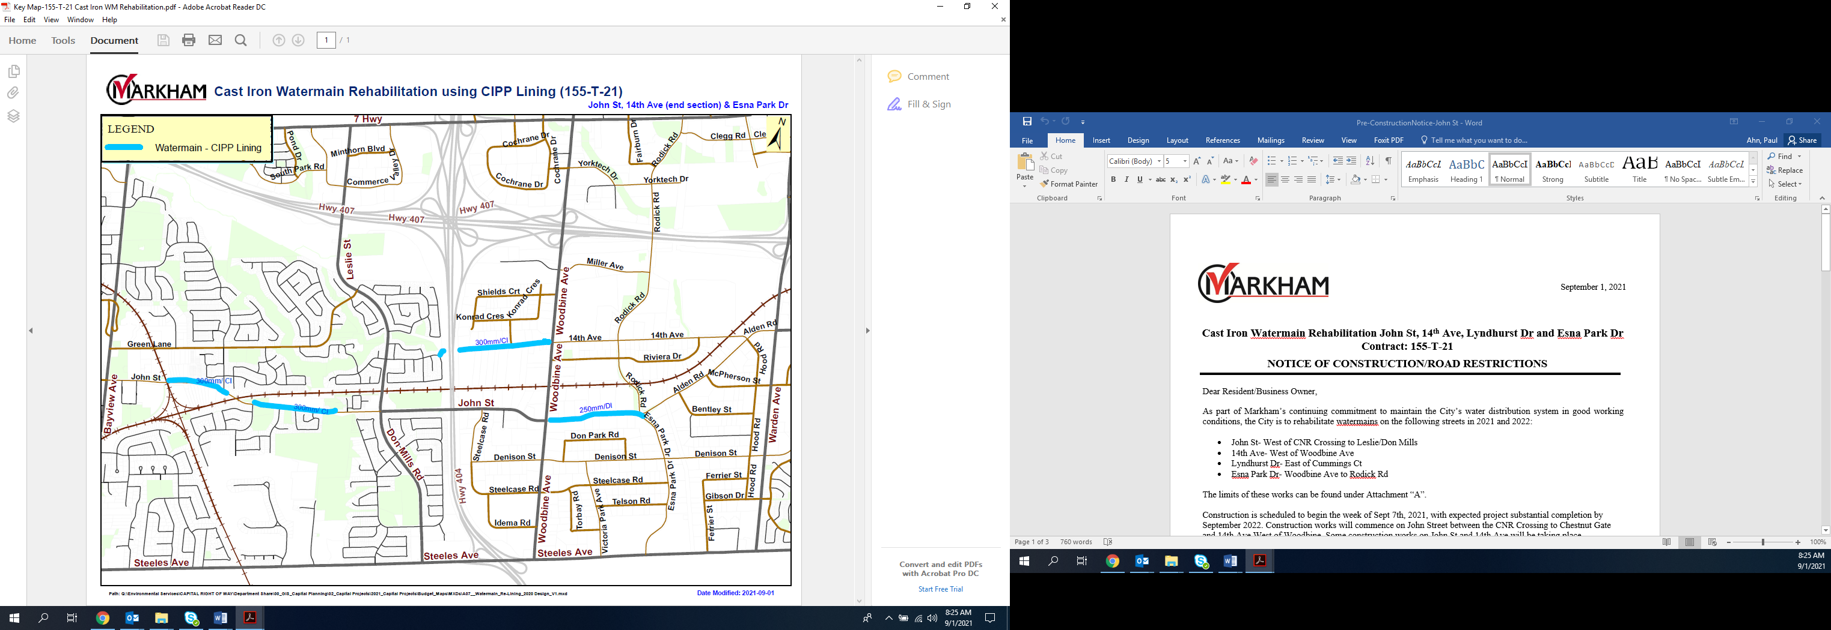

**Attachment “A” – Construction Area**